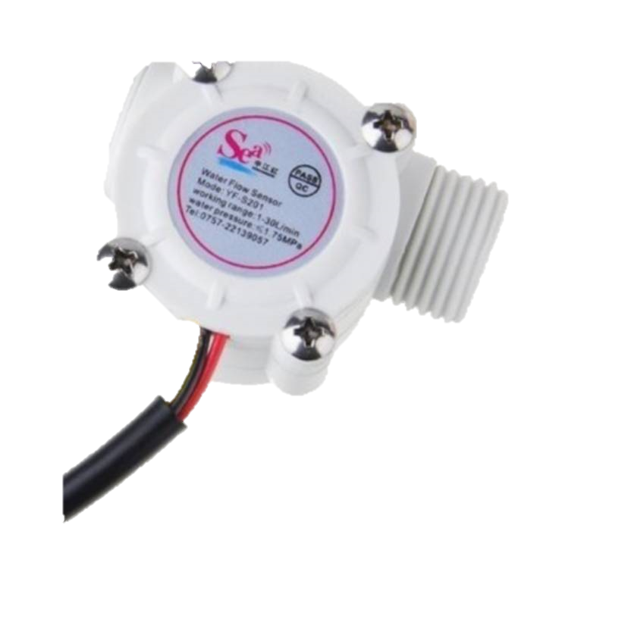

This sensor sits in line with your water line and contains a pinwheel sensor to measure how much liquid has moved through it.

There's an integrated magnetic Hall Effect sensor that outputs an electrical pulse with every revolution.

The Hall Effect sensor is sealed from the water pipe and allows the sensor to stay safe and dry. [1]

The sensor comes with three wires: red (5-24VDC power), black (ground) and yellow (Hall Effect pulse output).

By counting the pulses from the output of the sensor, you can easily calculate water flow.

Each pulse is approximately 2.25 milliliters.

Note this isn't a precision sensor, and the pulse rate does vary a bit depending on the flow rate, fluid pressure and sensor orientation.

It will need careful calibration if better than 10% precision is required. However, it’s great for basic measurement tasks! We have as example Arduino sketch that can be used to quickly test the sensor, it will calculate the approximate flow of water in liters/hour.

The pulse signal is a simple square wave so it’s quite easy to log and convert into liters per minute using the following formula.

Pulse frequency (Hz) / 7.5 = flow rate in L/min.

Flow Rate (Liters/hour) = (Pulse frequency x 60 min) / 7.5Q

**Features:**

•Model:

• Sensor Type: hall Effect

• Working Voltage: 5 to 18V DC (min tested working voltage 4.5V)

• Max current draw: 15mA @ 5V

• Output Type: 5V TTL

• Working Flow Rate: 1 to 30 Liters/Minute

• Working Temperature range: -25 to +80℃

• Working Humidity Range: 35%-80% RH

• Accuracy: ±10%

• Maximum water pressure: 2.0 MPa

• Output duty cycle: 50% +-10%

• Output rise time: 0.04us

• Output fall time: 0.18us

• Flow rate pulse characteristics: Frequency (Hz) = 7.5 * Flow rate (L/min)

• Pulses per Liter: 450

• Durability: minimum 300,000 cycles

• Cable length: 15cm

• 1/2" nominal pipe connections, 0.78" outer diameter, 1/2" of thread

• Size: 2.5" x 1.4" x 1.4"

• Connection details: Red wire: +5V Black wire: GND Yellow wire: PWM output.

**Specifications:**

**General**

|  |  |
| --- | --- |
| * Sales Package | 1 x Water Flow Sensor YF-S201 |
| * Skillset | Analysis & Critical Thinking, Creativity & Imagination, Motor Skills, Problem Solving, Curiosity Building, Problem Solving, Sensory Development |
| * Number Of Batteries | 0 Batteries |
| * Minimum Age | 8 years |
| * Material | Plastic |
| * Screen Size | N.A. |
| * Screen Type | N.A. |
| * Battery Operated | No |
| * Battery Type | No batteries |
| * Rechargeable | No |
| * Audio Features | No Audio |
| * Safety Features | Non-toxic |
| * Country Of Manufacture | India |
| * Other Features | Easy to use |

**Dimensions**

|  |  |
| --- | --- |
| * Width | 57 mm |
| * Height | 26 mm |
| * Depth | 34 mm |
| * Weight | 40 g |
| * Box Depth | 10 cm |
| * Box Height | 7 cm |
| * Box Weight | 100 g |
| * Box Width | 12 cm |

**Features**:

* Digital flow meter measuring flow rate from 0.05 m3 / hr to 500 m3/hr.
* Combined indicator, Totalizer, Batcher, Rate switch
* Dual sensor, dual line, single meter, for RO applications
* Remote reset. (auto/manual)
* Optional computer interface with RS485 / RS232
* 4-20 mA output

**Technical Specifications:**

|  |  |
| --- | --- |
| **Physical Dimensions** | 105 x 105 x 120 mm |
| **Cutout Size** | 92 x 92 mm |
| **Enclosure** | ABS Weather proof |
| **Mounting** | Field / Panel |
| **Supply Power** | 230V A.C. / 115V A.C./ 24V (200 mA) DC |
| **Display Range** | 0 - 999999.9 m³ /hr 0 - 9999999 liters |
| **Accuracy** | ± 2% FSD |
| **Alarms / Control Relay** | 1 no. 5 A @ 230 VAC |
| **Calibration / Set Point** | Using front panel keypad |
| **Input** | From Sensor |
| **Output** | Relay output for batch quantity 4 -20 mA (optional) RS 485 (optional) |

**Options**

* ***BATCHER AND TOTALIZER***  
  Relay gets energized after a fixed quantity of water passes through the sensor. The batcher has a **auto reset, manual reset & dual relay** operation facility. Batch quantity counts downwards till zero value.
* ***FLOW COMPARITOR***  
  The meter is supplied with two sensors for **RO** permeate and reject line. The meter displays both the flow rates and calculates **percentage recovery.**
* ***RATE SWITCH MODE***  
  The relay is programmed to get energized whenever actual flow falls below the set value. Display shows **"LOW FLOW RATE".**
* ***COMPUTER INTERFACE***  
  **RS 232O/P** which can be directly connected to a serial port printer or PC to record data with date and time.**RS485 O/P** with interface box for **multi channels data logging.(max** **32 channels)**
* ***PULSER***  
  Meter can be configured to any metering /dosing pump.**Chemical dosing can be done on-line proportional to flow.**
* ***Optional Data Logger***

The flow meter is available with data logger option where flow rate & total flow with date and time is stored in a **2GB Memory** card

### Additional Information

AT AT89S52

1.